


Renal Transplantation – Anaesthetic Guidelines
Dr C Bianchi, Dr D Cunningham, Dr E Loh
Dr C Tosini, Dr E Williams

These guidelines are meant to help the anaesthetists managing renal transplant recipients at St George’s Hospital, either in the deceased or living donor transplant setting.
As for all guidelines, they do not replace a clinician’s own judgement or good medical practice principles.

1. Preparation and planning
- Look for work-up sheets and MDT meeting minutes in the paper notes/EPR/Iclip: they often contain most of the necessary information (which is regularly updated): particularly cardiovascular investigations and recommendations about the need of invasive monitoring intra-op and post op destinations.

- Review the patient: ensure no intercurrent issues and check:
  - State of hydration: Most patients will have had a recent dialysis session. Consider the possibility of hypovolaemia during transplant.
  - K+ and Ca levels: Likely chronic metabolic acidosis on ABG (if available).
  - Clotting status: check pre- and/or possible intra- and post-op use of anti-platelet or blood thinning agents: Haematology plan should be highlighted in the notes if the patient on any anticoagulant agents.
  - Valid group & save or cross matched units depending on Hb levels. If <80 g/L, packed red blood cells are usually required for intraoperative transfusion. Comorbidities /special circumstances may cause the threshold to vary.

- Consider RSI if high risk of aspiration; delayed gastric emptying possible.
- Use theatre briefing to discuss fully with the surgeon and the team the overall intraoperative strategy, including agreement on use of intraoperative drugs such as vasopressors, mannitol, immunosuppressants and antibiotics.
- Plan with ODP about invasive (arterial line and Flow trac) vs non-invasive monitoring (Edwards ClearSight system) as below. The use of cardiac output monitoring, either invasive or non-invasive, is strongly recommended.

2. Intraoperative management
- Protect existing AV fistulae: consider wrapping loosely the arm in gamgee. Ensure no drips or BP cuff on AV side.
- Peripheral cannulation: if multiple options, avoid obvious sites for future fistulae, such as the cephalic vein at the wrist or elbow crease. Start with small-bore IV access, then large-bore peripheral IV cannula after induction.
- Choice of haemodynamic monitoring: use your clinical judgement on a case-by-case basis and the monitoring tools you are comfortable with. Arterial lines recommended only in high-risk patients as per MDT discussion. Consider non-invasive cardiac output monitoring for all patients with Edwards ClearSight system that is now available in all theatre suites and allows close BP monitoring and goal directed fluid therapy. Oesophageal doppler still available if needed.
- Central lines: consider CVP lines if there is an anticipated need for noradrenaline infusion intraoperatively. Existing haemodialysis lines may be used in case of poor access or if an emergency occurs. Remember they are all heparin locked. Aspirate 3-5 mL of blood from port before use; re-lock with heparin after use.
- Vascaths are not required routinely unless discussed previously at the briefing or indicated on the MDT PLAN.
- Train-of-four monitoring: essential. Serious incidents have occurred with vessel lacerations due to inadequate neuromuscular blockade.
- Maintain normothermia (Bair Hugger, fluid warmer). Continuous temperature monitoring.

Induction
- Propofol + fentanyl appropriate for most cases; consider possibility of haemodynamic instability at induction and titrate induction drugs accordingly.
- Atracurium and Rocuronium can be both used. Sugammadex can be used at normal dosages for rocuronium reversal. Avoid suxamethonium

Maintenance

- Sevoflurane +/- N2O;
- Keep FiO2 around 0.5, especially if IHD/reduced O2 carrying capacity.
- Further neuromuscular blocking drugs as directed by nerve stimulator. Aim for TOF < 1.
- Fentanyl and paracetamol for analgesia.
- Consider TIVA if confident but be aware of possible haemodynamic instability and the need of maintaining good MAP.
- It’s essential for transplant patients to maintain good perfusion pressure throughout anaesthesia. Aim for a higher MAP target of not less than 20% than the baseline (always more than 70-75mmHg).
- Blood If indicated (as above), use venous gas/ Haemocue for Hb readings as needed.
Intraoperative Fluid Management

Guided by invasive (FlowTrac /Oesophageal doppler) or non-invasive (Edwards
ClearSite System) cardiac output monitoring.

- Clinician Bolus – 500ml of Compound Sodium Lactate at the start of procedure.
- Maintenance fluid of Compound Sodium Lactate at rate of 5ml/kg/hr via volumetric pump.
- Further Fluid boluses guided by haemodynamic monitoring as per flow chart (Figure 1).

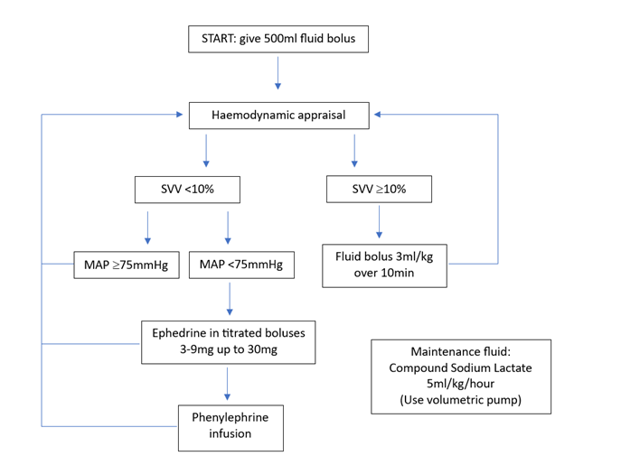
Figure 1: Guide to intraoperative fluid management for renal transplants
Other drugs
- Antibiotics: co-amoxiclav 1.2g IV, alternative protocol for penicillin allergic patients.
- Immunosuppressants: renal staff will take to theatre methylprednisolone 500mg and basiliximab 20 mg for IV administration. Both must have been given by the time the kidney is re-perfused (best given after induction). Check against prescription/discuss with surgeon/nephrologists if drugs brought to theatre with the patient differ from the above protocol.
- Heparin/mannitol may be requested by the surgeon depending on circumstances; ideally, discuss at theatre briefing.
- Reversal with neostigmine/glycopyrrolate; sugammadex at normal dosages if rocuronium has been used.
- Vasopressors: do not use metaraminol unless emergency/peri-arrest. For BP management after adequate fluid amounts given, consider ephedrine bolus or phenylephrine infusion.

3. Postoperative management
- Fluids and drugs Electronically prescribed via PowerChart. There is an Anaesthesia *Adults* Renal Transplant PowerPlan on iClip which includes all the most common drugs and renal transplant-specific fluid replacement.
- Select drugs and dosages as appropriate. The fluid management protocol is already included in the ‘Continuous details/infusion instructions’ section of Hartmann’s bags. Ensure other concurrent infusions (e.g., sliding scale) are included when calculating post operative fluid requirements.
- Analgesia protocol - fentanyl or oxycodone PCA + regular paracetamol +/- infusion of 0.125% L-bupivacaine at 1-13 mL/hour through ‘epidural’ catheter inserted by the surgeon between wound layers (check with surgeon first if they will use it or not).
- Transfer to Champneys ward when observations in recovery are satisfactory.
- Continue O2 therapy by simple mask/nasal specs whilst patient on PCA.
- Admission to HDU/ITU: Check patient work-up sheet or MDT meeting minutes. If no HDU/ITU bed available, a longer stay in Recovery may be acceptable.

- Updated by Dr C Bianchi, Dr D Cunningham & Dr E Loh August 2023
- Review date in Oct 2025.

